8 Money Laundering patterns are illustrated in Figure :
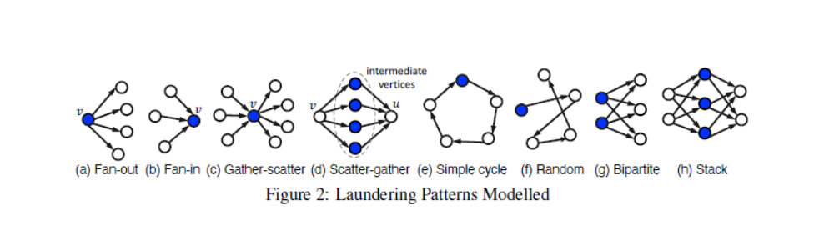

To be more precise, a fan-out pattern of vertex v, shown in Figure 2a, is defined by the outgoing edges of v connecting v to at least k ≥ 2 different vertices [58]. Analogously,
for a fan-in pattern, shown in Figure 2b, v is connected to k ≥ 2 different vertices via incoming edges.
A gather-scatter pattern combines a fan-in pattern with a fan-out pattern of the same vertex, as illustrated in Figure 2c [55].
A fan-out pattern of a vertex v and a fan-in pattern of a vertex u form a scatter-gather pattern if the fan-out and the fan-in patterns connect vertices v and u, respectively, to the same set of intermediate vertices [55]. Figure 2d shows an example of a scatter-gather pattern with four intermediate vertices.
A simple cycle pattern, shown in Figure 2e, is a sequence of edges that starts and ends with the same vertex and visits other vertices at most once [27, 12]. Figure 1 shows a cycle in the financial transaction graph, in which node A launders money through nodes C and D.
A Random pattern, depicted in Figure 2f, is like the cycle pattern in Figure 2e – except with random funds are not returned to their original account. As such, random can be viewed as a random walk among accounts owned or controlled (e.g. through shell companies).
A bipartite pattern in Figure 2g moves funds from a set of input accounts to a set of output accounts.
Finally, a stack pattern in Figure 2h extends the bipartite pattern by adding an additional bipartite layer.
In these cases, as with all the laundering patterns, the laundering entity owns or controls all accounts (nodes) used. For example, an entity may “control” shell companies, that appear to “own” an account.
Over the years, rules have become stricter about who is the Ultimate Beneficial Owner (UBO) of an account. However, accurate UBO designations can be difficult to enforce or detect. Note also that some entities own or control more nodes than others, and thus can have larger patterns or more variation in their node selection.
Overall 1 in 1,750 transactions is laundering in LI-Large. For comparison, Starnini et al. [56] report on real data with 180M transactions over 6 months from a major Italian bank. They find 855 laundering motifs (equivalent to our Gather-Scatter and Scatter-Gather patterns), each with “less than 20 [nodes] total”. This amounts to around 1 laundering transaction per 21,000. By comparison Appendix Table 7 indicates LI-Large has 8,212 combined Gather-Scatter and Scatter-Gather transactions – yielding a very similar 1 laundering transaction per 21,440 transactions from these patterns.

